Jevonte Frederick
CS-320
12/14/2025
Project Two
My approach aligned with software requirements by building unit tests for the constraints of each three features. For example,
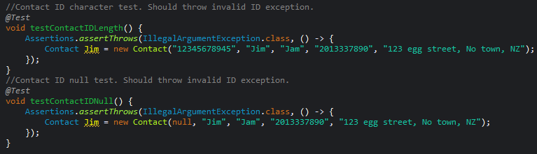These are the unit tests I created for the Contact class requirements of the ID attribute. TestContactIDLength() and testContactIDNull() verify that the ID attribute of the Contact class cannot be longer than 10 characters and cannot be null respectively. The first test tries to create the Contact object with the ID “1234567845” that is an 11-character String, and the second test initializes ID as null. Each test asserts an exception is thrown from my code so that Contact objects must have an ID no greater than 10 characters and cannot be null.
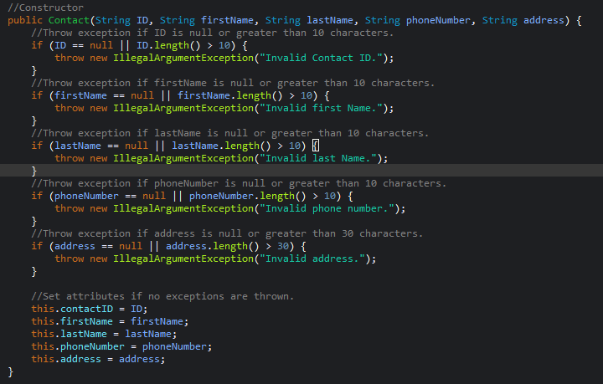This is the code in my Contact class that is tested from these unit tests. If ID is either null or greater than 10 characters, then an illegal argument exception is thrown to match requirements. I repeated this for all the attributes of the Contact, Task, and Appointment classes with individual unit tests. This portion of my code is also technically sound because each attribute is validated before the object is fully initialized. If any attribute is invalid, then the object should not be initialized, and an exception is thrown. Once all my unit tests passed, I believed I met all the requirements for each class. My unit tests were additionally effective because I had 100% coverage for the Contact, Task, and Appointment class. My service classes had nearly 100% coverage based on the results. And for the service classes, my service unit tests verified that objects could not be deleted or changed if an ID is not found in the data structure. My function to add objects to the data structure threw an exception if a new object has the same ID as an existing object in the data structure. To prevent IDs from being changed, my updateContact() and updateTask() functions use the ID to find a stored object but cannot change the ID of an existing object, which meets the requirements that IDs cannot be altered.
My code was also efficient by making use of a HashMap for the service classes.
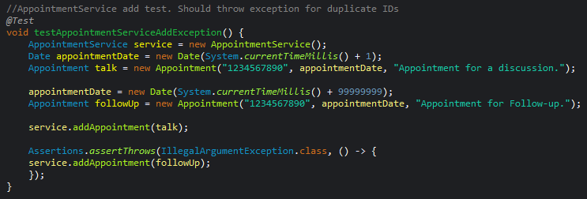This is my unit test to verify that duplicate appointment IDs cannot be added to the AppointmentService data structure.
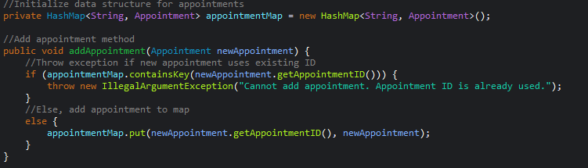This is the code of my AppointmentService class to add objects to the HashMap. It was efficient to use a HashMap because using the ID as a key to the objects stored as a map value made it easy to retrieve objects. This helped develop the service class functions to add, delete, or update an existing object and check if an ID already exists.
The testing techniques I used were unit testing and integration testing. My unit testing verified small components, such as the Appointment class not accepting a name longer than 20 characters. Additionally, I did integration testing for the interactions between the service class and its respective object class.
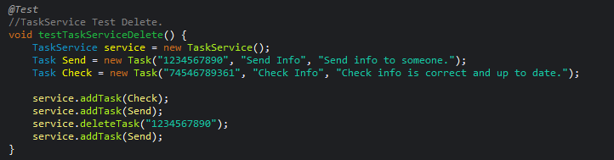This is a unit test I created to verify that the TaskService class works with the Task class. I initialized a Send and Check Task object with different IDs, added both to the TaskService HashMap, deleted the Send task from the map using its ID, and then added Send to the map again. This sequence tested that the TaskService can both delete and add Task objects in a sequence of instructions. My code would’ve thrown a duplicate ID exception if Send was not properly deleted by deleteTask(), so the test passing confirmed my service class interacted with the object class and was deleteTask() works as intended.
Other techniques I did not use were performance testing and security testing. Performance testing is an important technique to use as the reliability and stability of code is a crucial characteristic of quality software. This would include performing tests that check for bottlenecks and stress under high volumes of data. For example, testing that a data structure can add 500 objects within 30 seconds and can return data of an object within 5 seconds, is a performance test to consider. Based on the results of this, you would refactor code and optimize algorithms to improve performance. Next, security testing is also a high priority due to the standards of cybersecurity in the modern day. Code needs to be both secure and functional because vulnerable software causes as much damage as defective software. Security testing would include testing input sanitization, manually reviewing code for vulnerabilities such as weak encapsulation and unused code, and updating software dependencies. Both security testing and performance testing are integral to the modern testing lifecycle. Additionally, unit testing and integration testing are fundamental to quality code. Unit testing helps isolate the source of bugs in specific functions or blocks of code, and integration testing identifies bugs between modules of code. This should be done early in development to save both time and money as debugging is more efficient the earlier bugs are identified.
I used exercised caution in my project in a few ways.
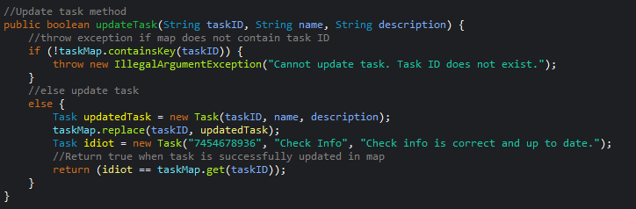This is an example of the updateTask() function in my ServiceTask class that returns a boolean to verify the HashMap successfully updated a Task object. I implemented this to ensure the intended functionality of my code. I’ve had difficulty in previous programs when changes to values in a data structure had unexpected results that were hard to find the root of. As a result, I exercise caution by verifying data structure operations to outline errors I may make in my code.
I tried to limit bias by checking for my own negativity bias. Negativity bias is, “the tendency to give more attention or more consideration to what is conceptually negative, instead of maintaining balance with the positive experiences or information” (Shenk, 2018). This was important because the requirements of the features made me focus on what to constrain and test, like the length limit of each attribute. It would have been easy to only test what I would expect to go wrong based on requirements and not perform positive unit tests. An example is my testTaskServiceAdd() unit test that verified that the TaskService class can add two objects to the HashMap that have valid attributes. This mitigated the negativity bias I initially had where my code and unit tests focused on what should throw exceptions and what I think is likely to have bugs. Creating positive tests to pass added a balance of normal functionality and cases of exception handling.
It’s important to be disciplined as a developer so you can efficiently design, document, and test your code. Cutting corners is never acceptable as a developer because it’s more of a shortcut to failure than success. Though it is efficient to make simple code, doing the bare minimum and overlooking aspects such as performance, security, and edge cases of the code will lead to bugs. Software with defects has a risk of harming users financially, emotionally, or physically depending on its deployment. Developers must follow best practices in creating code as a result. Testing should also be substantial because code can be designed well but still contains a risk of bugs and defects due to human error. In the future, I will minimize technical debt by following best practices for coding. This would include organized and repeatable testing with identifiable test names and comments to explain the purpose of each test. I should do this because “Code debt results from rushed development, inconsistent coding practices and poor documentation. When programmers take shortcuts—such as duplicating logic, using unclear variable names or failing to follow industry standards—the amount of technical debt accumulates, making debugging and maintenance time-consuming” (Mucci, 2025). So, it is important to document testing with best practices to reduce future difficulty maintaining code. This becomes even more relevant with increasingly complex programs that will make it easier to mishandle without proper documentation.

References
Mucci, T. (2025, March 27). Technical debt. Ibm.com. https://www.ibm.com/think/topics/technical-debt
Shenk, G. (2018, July 16). The Impact of Cognitive Bias on Software Testing. Functionize.com; Functionize Inc. https://www.functionize.com/blog/the-impact-of-cognitive-bias-on-software-testing

